Tutorial 4: STP

- A converged switch-based network with spanning tree protocol is shown in Figure 4.1. Which port is the root port for Switch W? Explain your answer in detail.
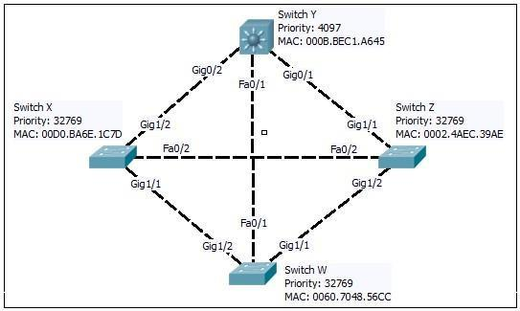
Figure 4.1 Network Topology

Device | Root bridge | Non-root bridge | Interface | Root port | Designated port | Block port
Switch W | ❌ | ✅ | Fa0/1 | ❌ | ❌ | ✅
Switch W | ❌ | ✅ | Gig1/1 | ✅ | ❌ | ❌
Switch W | ❌ | ✅ | Gig1/2 | ❌ | ❌ | ✅
Switch X | ❌ | ✅ | Fa0/2 | ❌ | ❌ | ✅
Switch X | ❌ | ✅ | Gig1/1 | ❌ | ✅ | ❌
Switch X | ❌ | ✅ | Gig1/2 | ✅ | ❌ | ❌
Switch Y | ✅ | ❌ | Fa0/1 | ❌ | ✅ | ❌
Switch Y | ✅ | ❌ | Gig0/1 | ❌ | ✅ | ❌
Switch Y | ✅ | ❌ | Gig0/2 | ❌ | ✅ | ❌
Switch Z | ❌ | ✅ | Fa0/2 | ❌ | ✅ | ❌
Switch Z | ❌ | ✅ | Gig1/1 | ✅ | ❌ | ❌
Switch Z | ❌ | ✅ | Gig1/2 | ❌ | ✅ | ❌

- The Spanning Tree Protocol (STP) is a network protocol that builds a loop-free logical topology for an Ethernet switched-based network. Based on Figure 4.2, provide answers with explanations to the following questions.

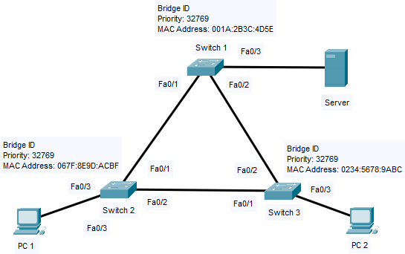

Figure 4.2: A switched-based network

  - Root bridge

Switch 1

  - Root port(s) on ALL non-root bridge.

Switch 2: Fa0/1
Switch 3: Fa0/2

  - Designated port(s).

Switch 1: Fa0/1, Fa0/2
Switch 3: Fa0/1

  - Blocked port(s).

Switch 2: Fa0/2

- Analyse Figure 4.3 and illustrate which switch will be elected as the root bridge and which switch’s port will place a port in blocking mode. Justify your answers.
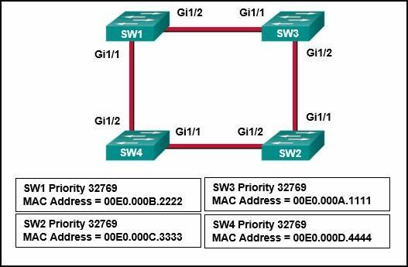
Figure 4.3 Network Topology

- Root bridge: SW3
- Non-root bridge: SW1, SW2, SW4
- Root port
  - SW1: Gi1/2
  - SW2: Gi1/1
  - SW4: G1/2
- Designated port
  - SW1: Gi1/1
  - SW2: Gi1/2
  - SW3: Gi1/1, Gi1/2
- Blocked port
  - SW4: Gi1/1

- The spanning tree algorithm (STA) uses four steps to achieve loop-free topology.
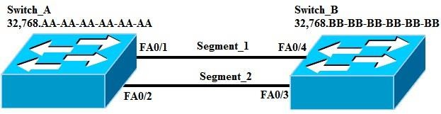

Figure 4.4 Network Topology

With reference to Figure 4.4, determine the following:
  - Root bridge

Switch_A

  - Non-root bridge

Switch_B

  - Root port on the non-root bridge

Switch_B: FA0/4

  - Designated port on Segment_1

Switch_A: FA0/1

  - Designated port on Segment_2

Switch_A: FA0/2

  - Non-designated port on Segment_2

Switch_B: FA0/3

  - The port in blocking state.

Switch_B: FA0/3

- STP has five ports states, list down the five ports state.

- Blocking
- Listening
- Learning
- Forwarding
- Disabled

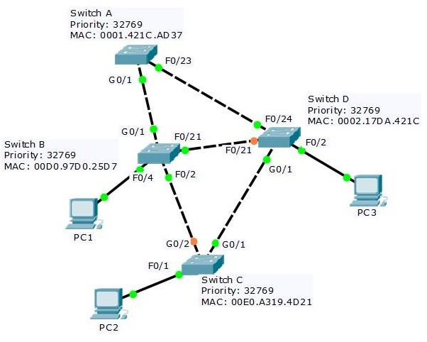
- Spanning Tree Protocol (STP) is a Layer 2 protocol that runs on switches.

Figure 4.5: Network Topology Based on Figure 4.5, determine the following:

  - Root bridge

Switch A

  - Root port on the non-root bridge

- Switch B: G0/1
- Switch C: G0/1
- Switch D: F0/24

  - Designated ports on the non-root bridge

- Switch B: F0/21, F0/2
- Switch D: G0/1

  - Non-designated port on the non-root bridge

- Switch C: G0/2
- Switch D: F0/21

  - Referring to Figure 4.5, suggest which of the switch(es) interfaces that need to be configured with PortFast and BPDU guard command? Justify your answers.

- Interface F0/4 on Switch B, interface F0/1 on Switch C and interface F0/2 on Switch D are needed to be configured with PortFast and BPDU guard commands.
- This is because these interfaces are connected to PCs which are end devices so STP does not need to wait for BPDUs.
- Enabling PortFast can ensure a faster transition to forwarding mode, preventing unnecessary delays in connectivity.
- Enabling BPDU Guard prevents unauthorized switches from being connected, reducing the risk of loops or STP recalculations.

